Install Local Server
Download the installer to your computer:
- X:\Installs\Microsoft\SQL Server\2022\enu_sql_server_2022_developer_edition_x64_dvd_7cacf733.iso
- Double-click the disk image to extract the files.
- On the image drive run the setup file.
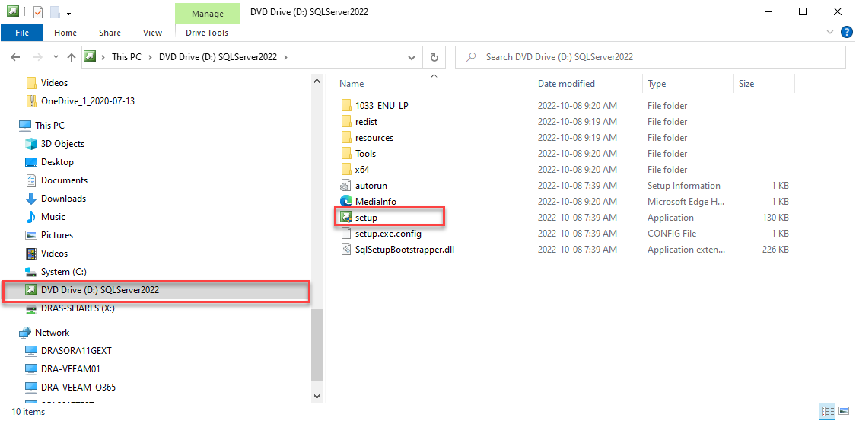

- Click Yes to run the setup.
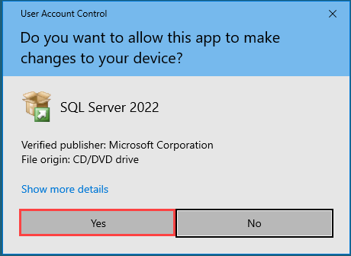
- Select Installation on the SQL Server Installation Center page.
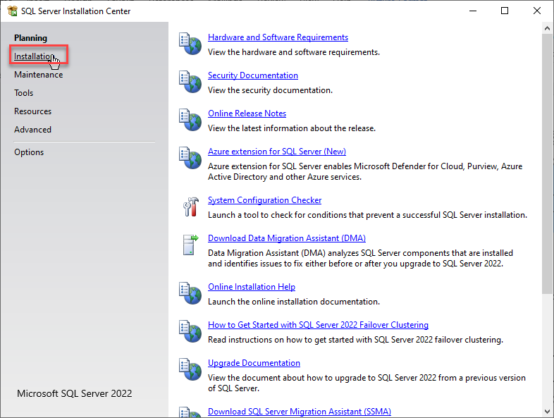
- Select New Server standalone installation … from the right panel of the SQL Server Installation Center page.
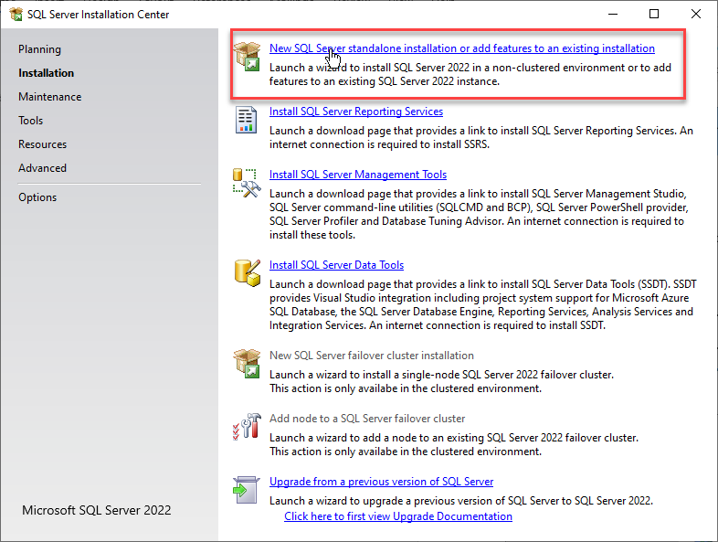

- Click Next.
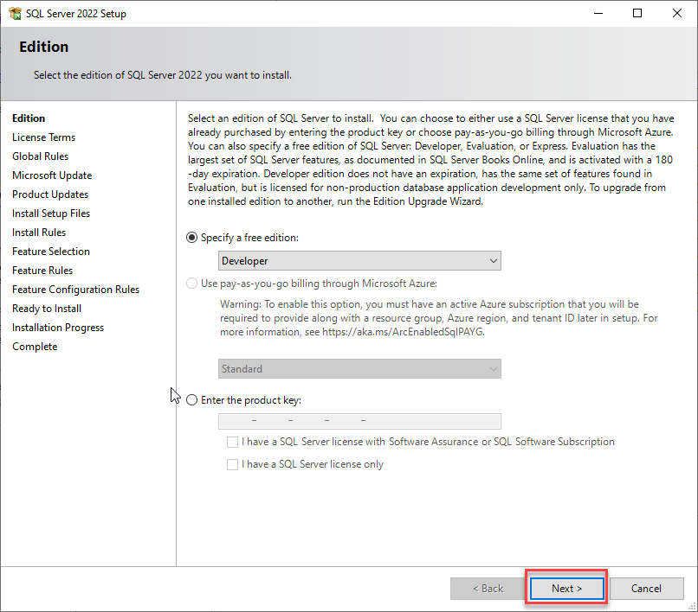

- Accept the license terms and
- Click Next.
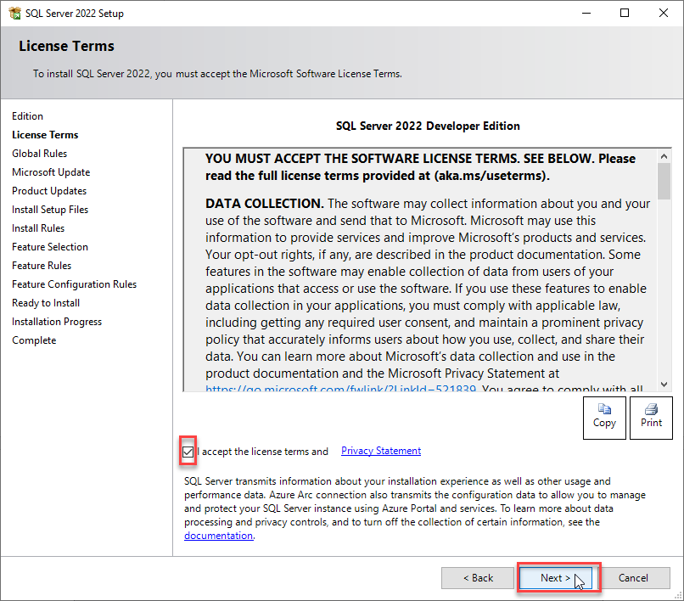

- Click Next.
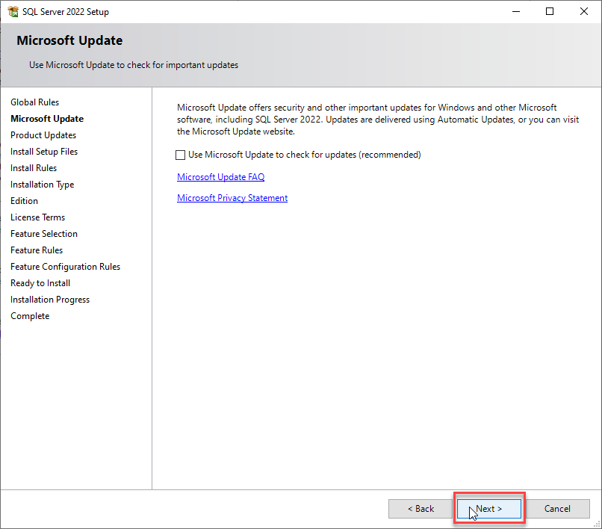

- Click Next.
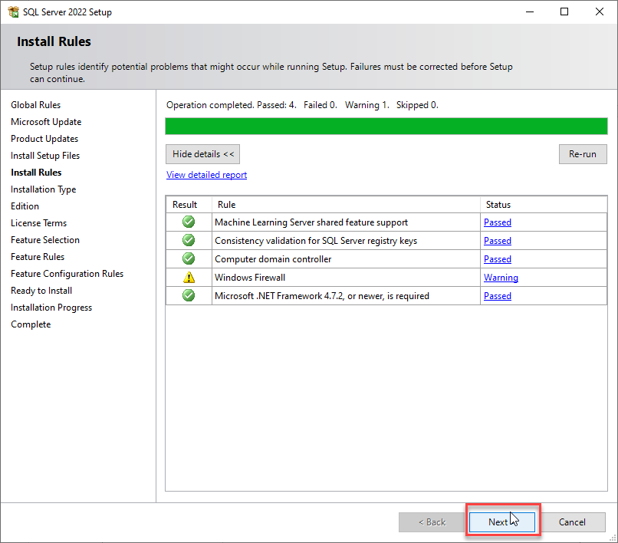

- Select Database Engine Services from the Instance Feature section in the right panel.
- Click Next.
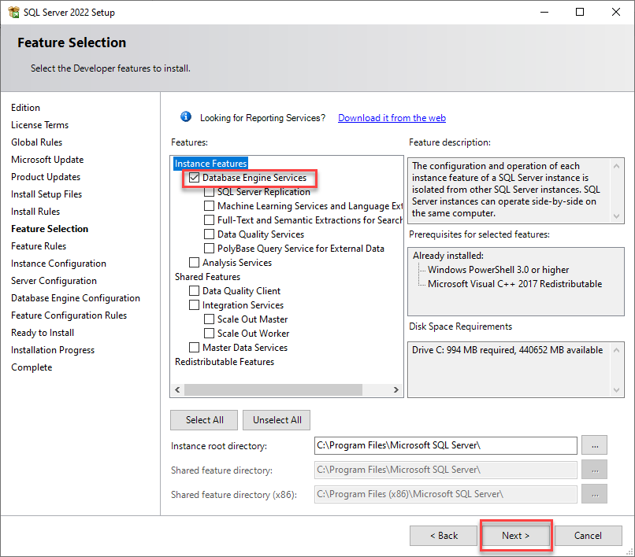

- Select the Default Instance option.
- Click Next.
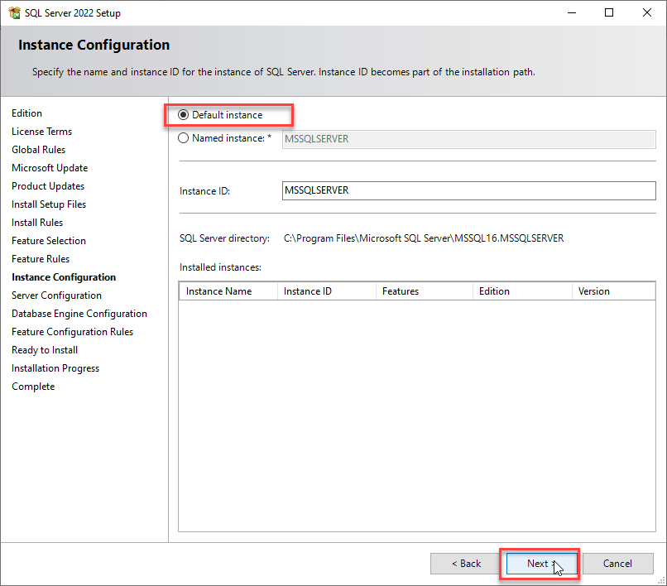

- Click Next.
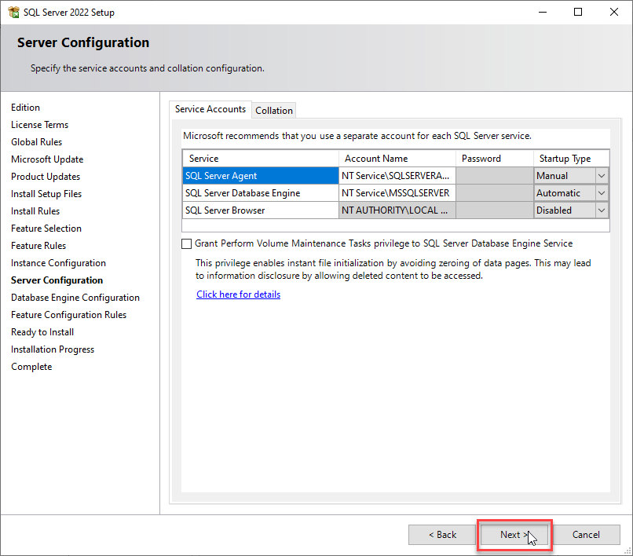

- Click the Add Current User button in the Specify SQL Server administrators section.
  - This will add you as an Administrator.
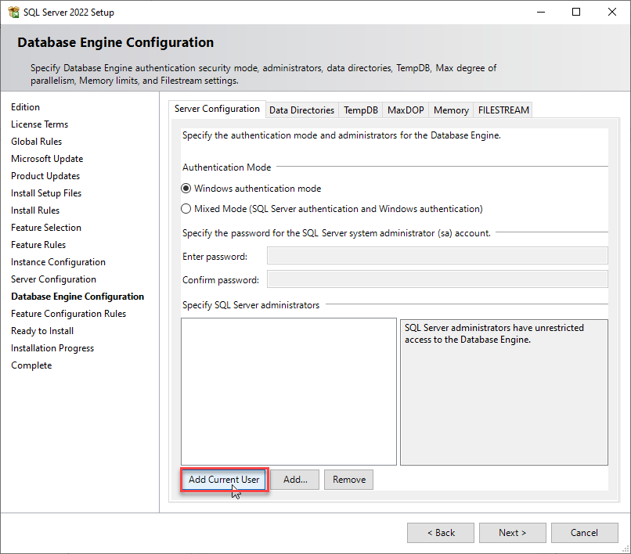

- Click the Add button.
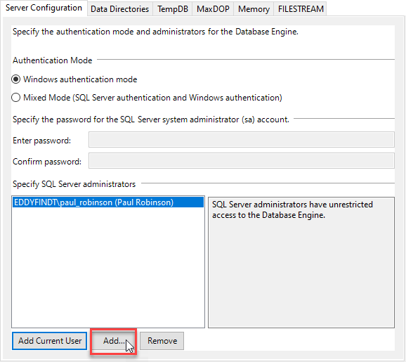

- Type DBA in the Enter the abject names to select test field
- Click Check Names.
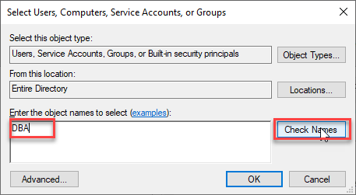

- Ensure that DBA is selected if multiple names are found.
- Click OK.
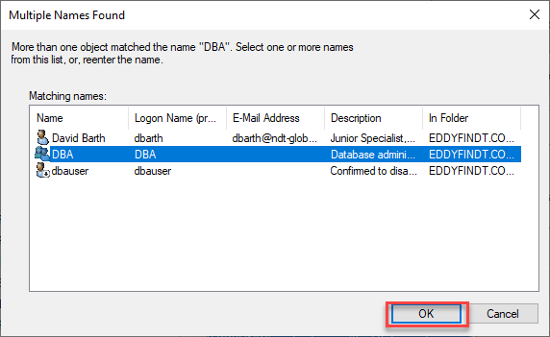

- Click OK again.
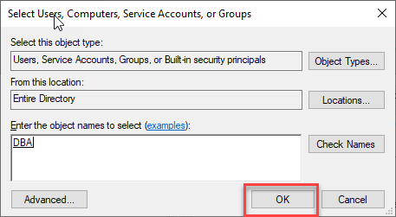

- Click Next.
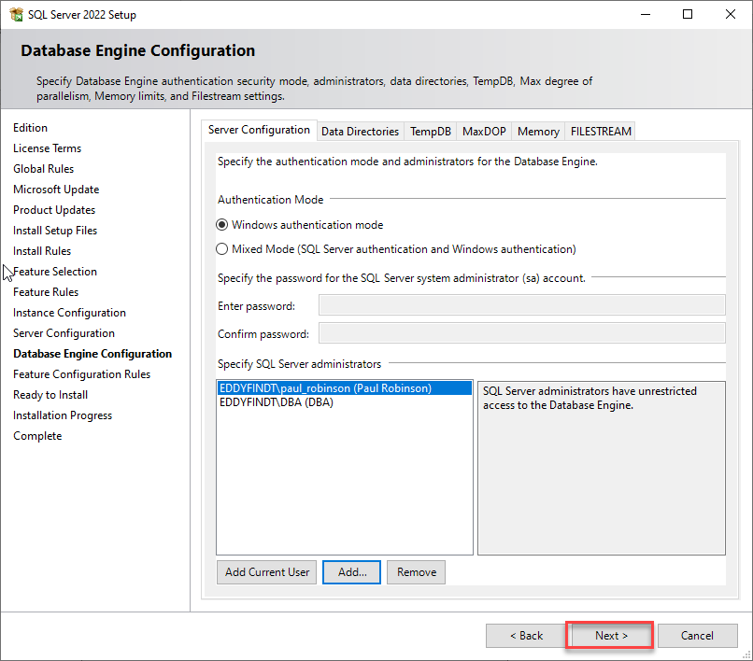

- Click Install.
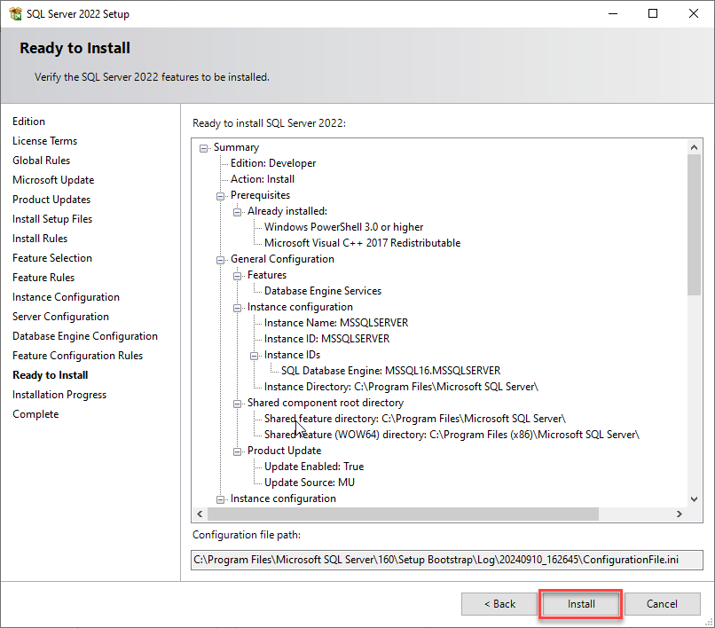

- Click Close.
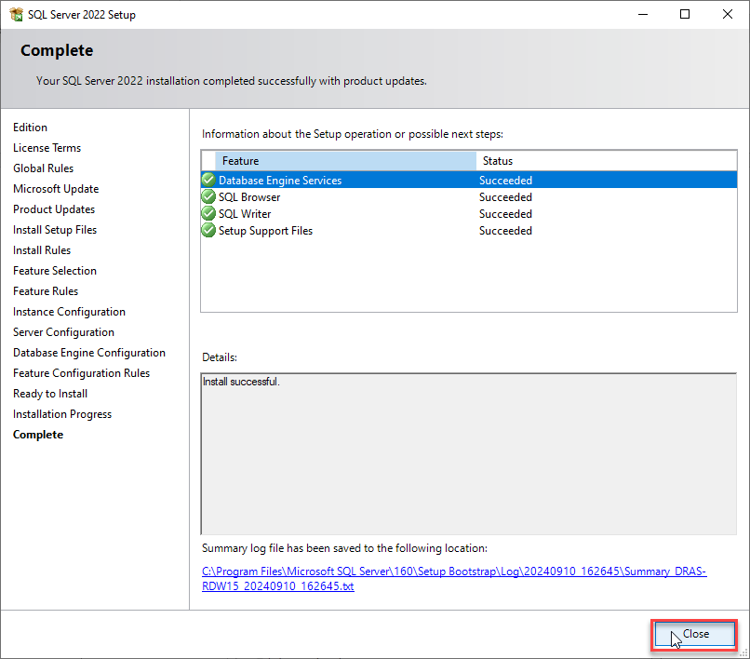

Enable SA account
Open the SSMs application.
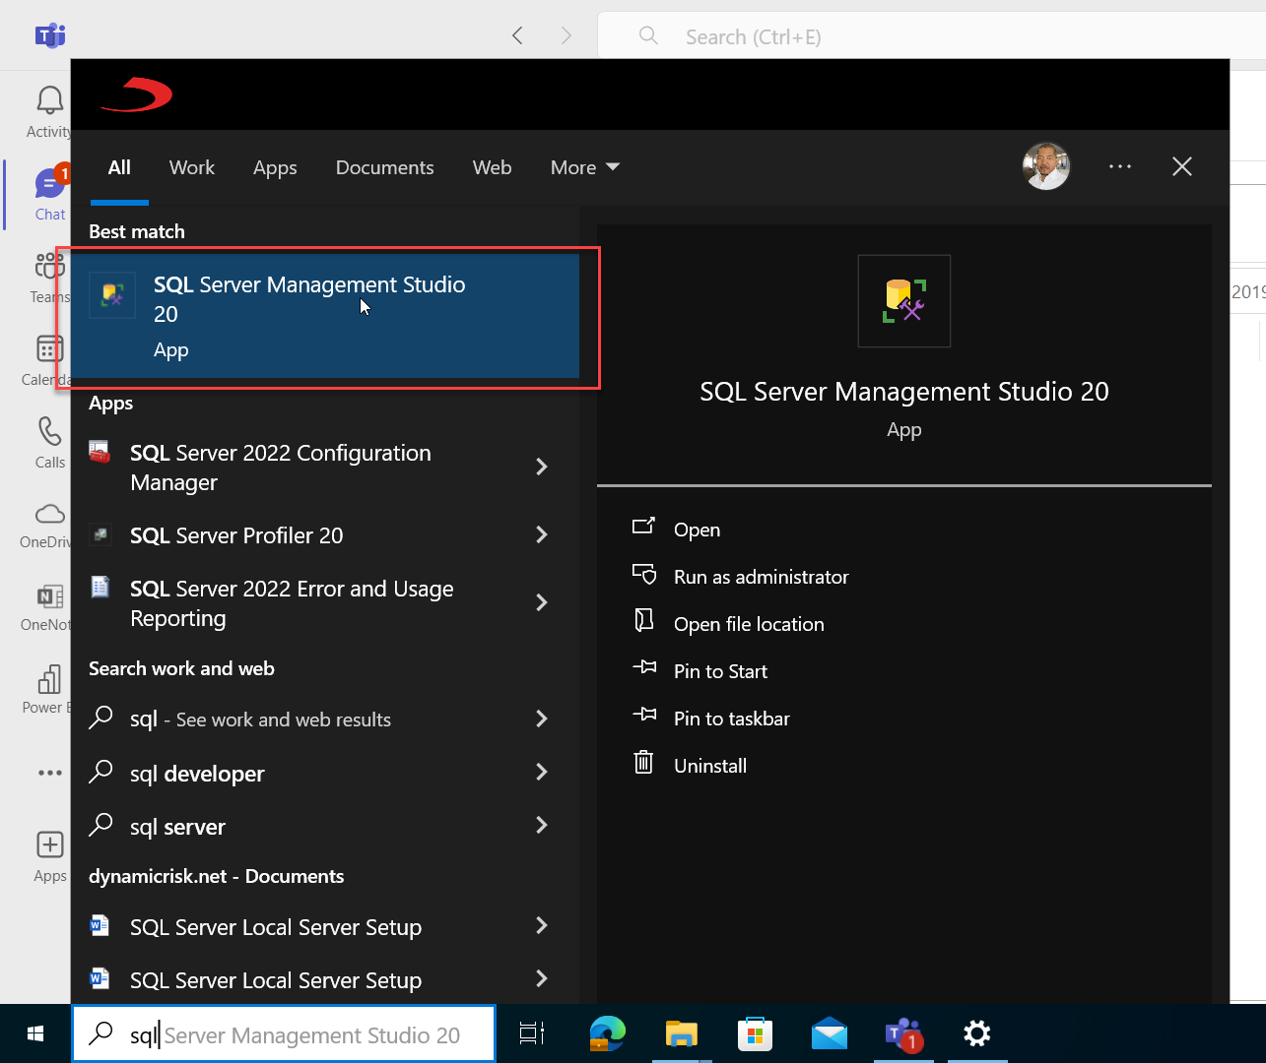

Connect to your local server.
- Select your computer name from the Server Name drop-down list.
- Check the Trust server certificate checkbox.
- Click Connect.
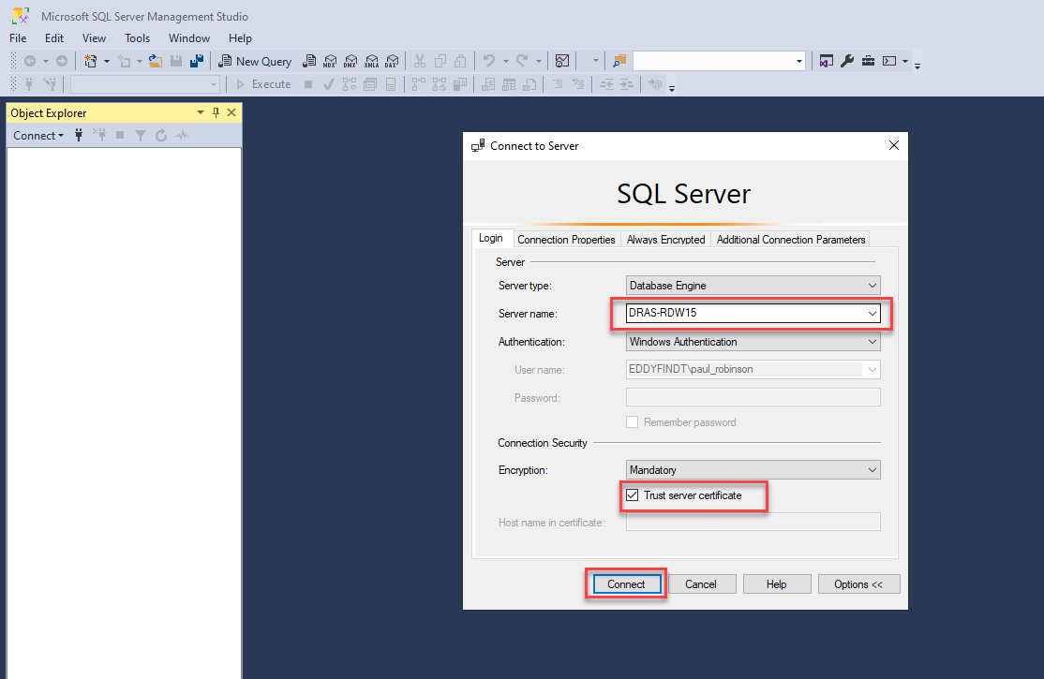

- Right-click the connection and select Properties from the context menu.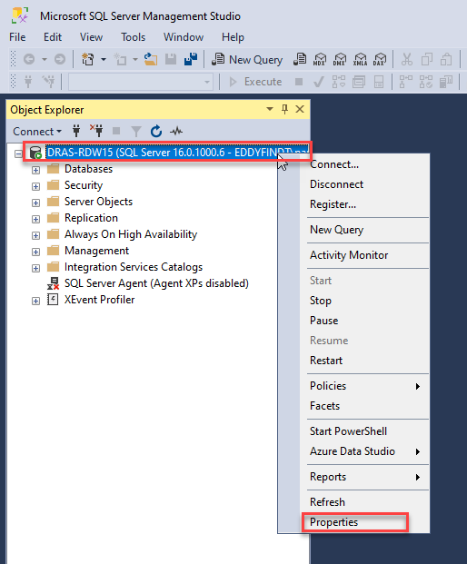

- Select Security from the Select a page group in the navigation panel.
- Under the Server authentication section select SQL Server and Windows Authentication mode.
- Click the OK button.
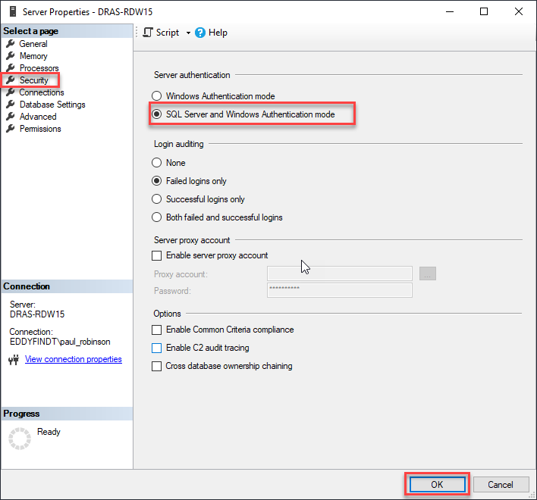

- Click OK.
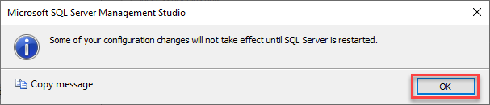

- Right-click the connection and select Restart from the context menu.
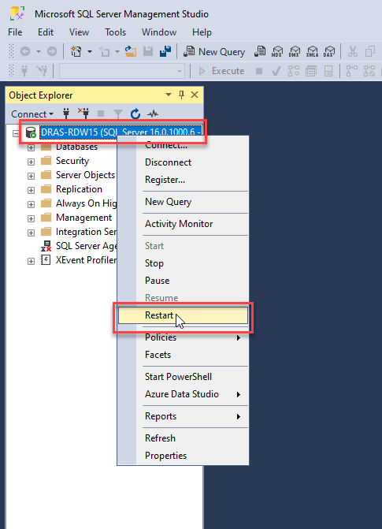
- Click the Yes button on the User Account Control dialog.
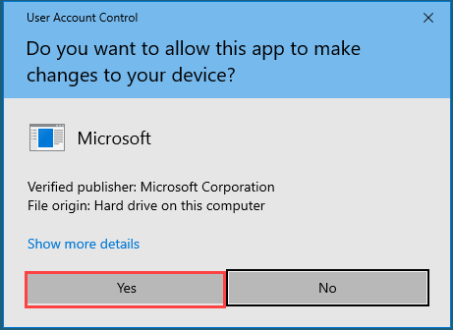

- Click Yes.
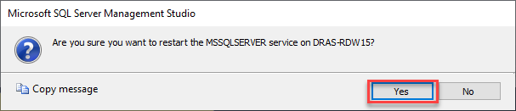

- Expand the Security node and select Logins.
- Double-click on the sa login.
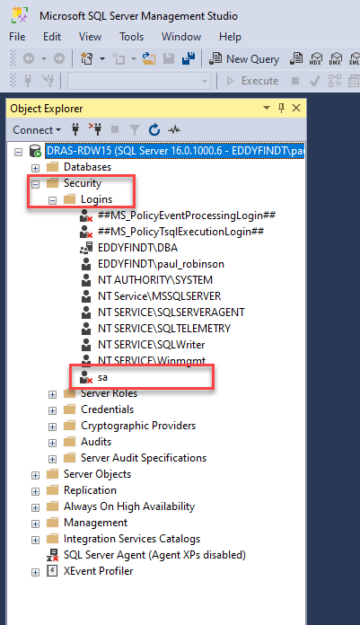

- Change sa the password in the Login Properties page.
  - Ensure the new password matches our password criteria.
    - Note: it must be at least 14 characters long (not 13).
- Click the OK button.
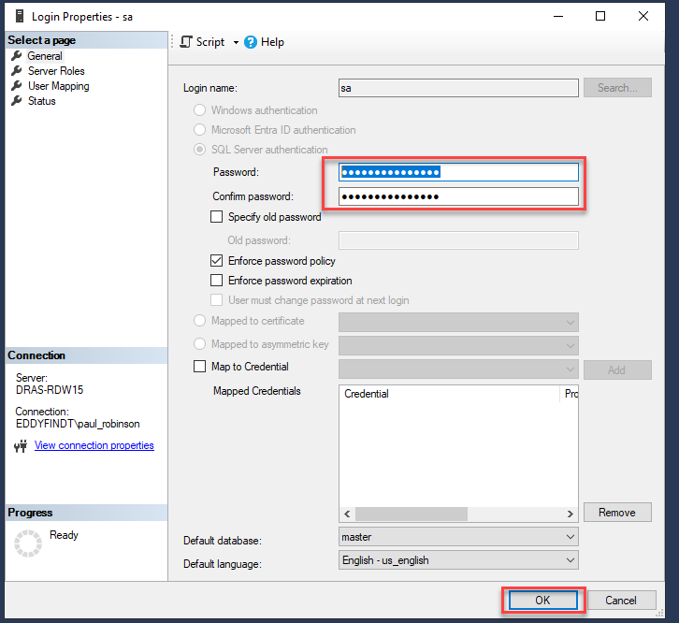

- On the Status node and select Enabled under the Login section.
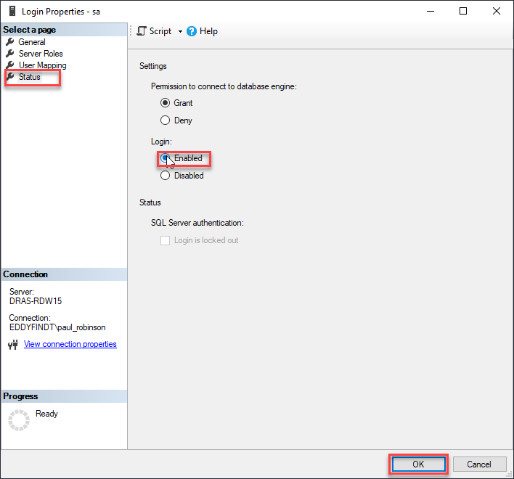

- Refresh the connection.
- The sa login should no longer have an x beside it.
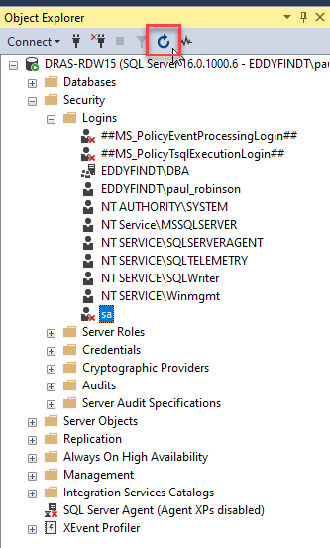

- Select Database Engine from the Connect drop-down list.
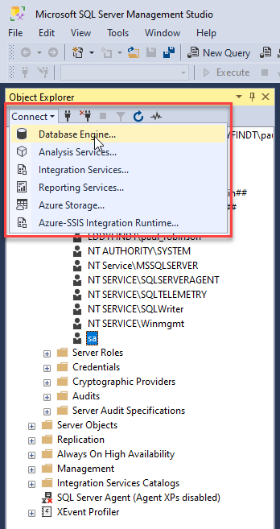

- Select SQL Server Authentication from the Authentication list.
- Ensure the Trust server certificate checkbox is checked.
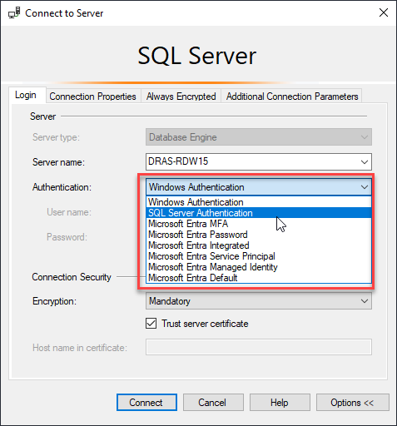

- Enter your password.
- Click the Connect button.
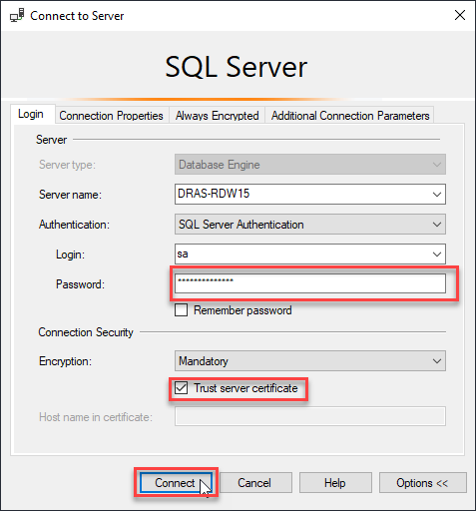

- You should now have 2 connections to your local server. One under your account and the other under the sa account.
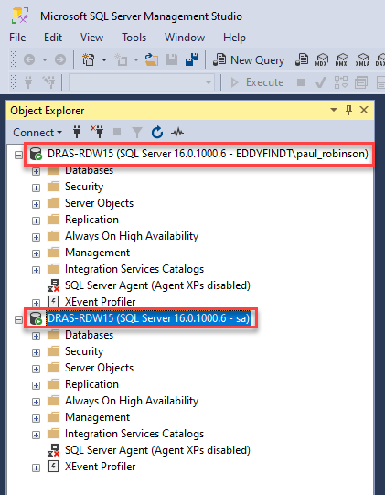

- Close the application.

Enable Named Pipes and TCP/IP

- Select Microsoft SQL Server 2022 from you Start menu
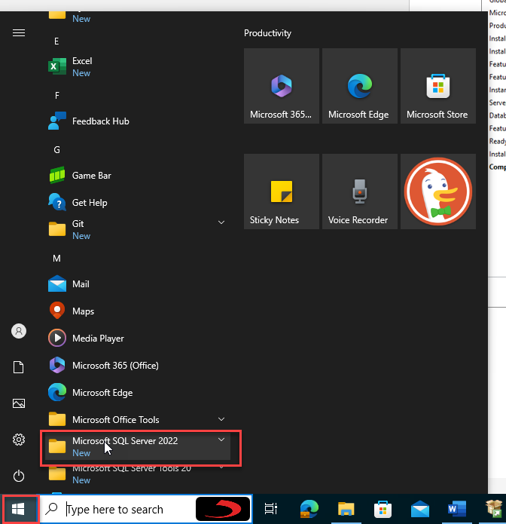

- Select SQL Server 2022 Configuration Manager from the drop-down list.
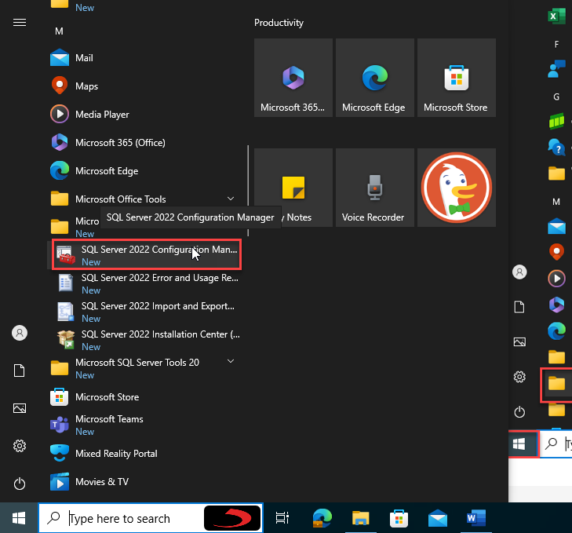

- Click Yes.
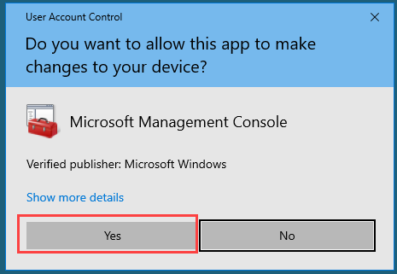

- Expand the SQL Server Network Configuration node and select Protocols for MSSQLSERVER.
- Right-click on Named Pipes and select Enable.
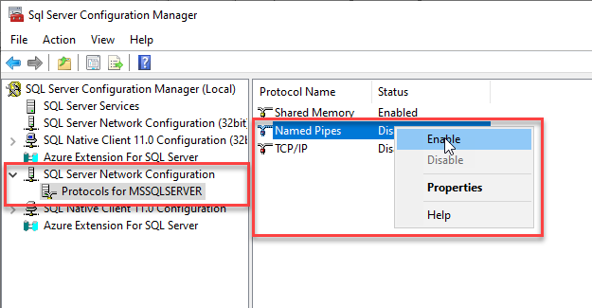

- Click the OK button.
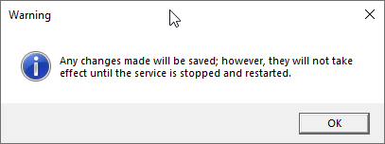

- Right-click on TCP/IP and select Enable.
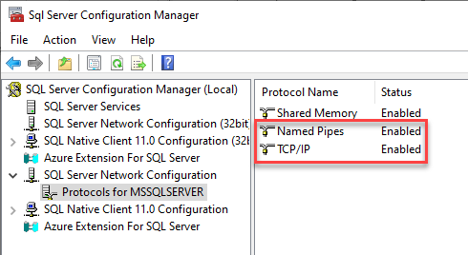

- Close the Configuration Manager.
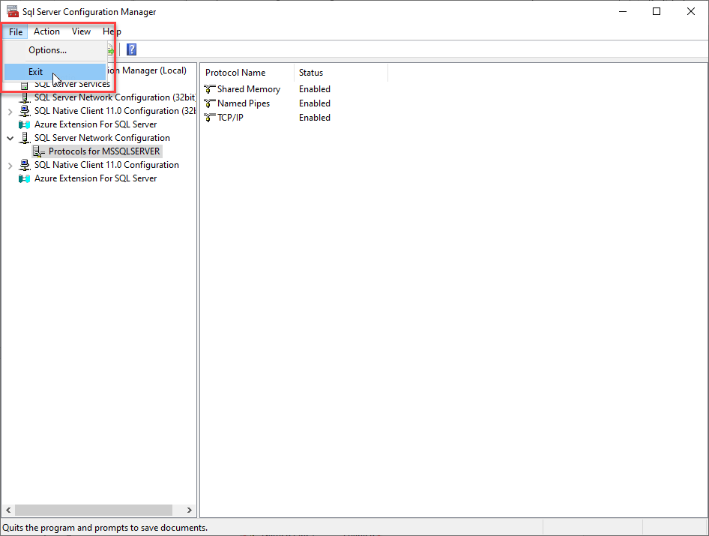

- Then restart your computer.

